BOUND
Pearson Edexcel - Thursday 9 June 2016 - Paper 2 (Calculator) Higher Tier
1.
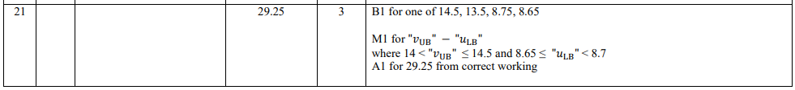
Pearson Edexcel - Friday 6 November 2015 - Paper 2 (Calculator) Higher Tier
2.
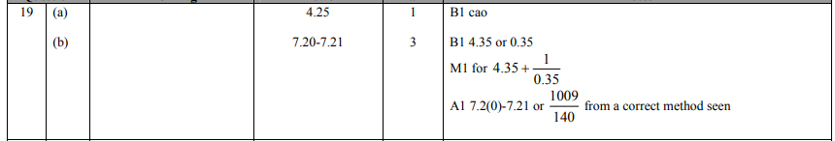
Pearson Edexcel - Monday 8 June 2015 - Paper 2 (Calculator) Higher Tier
3.
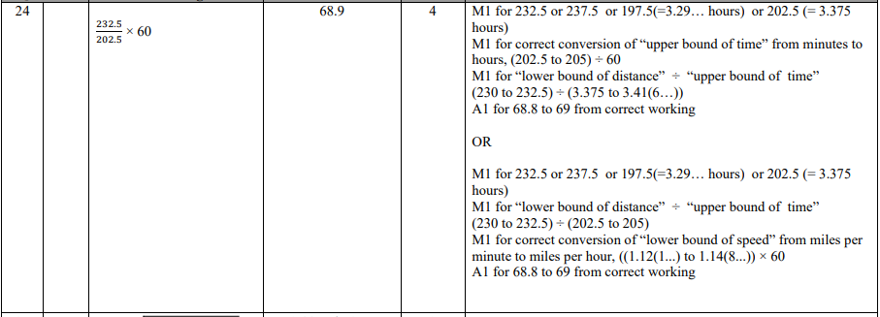
Pearson Edexcel - Friday 14 June 2013 - Paper 2 (Calculator) Higher Tier
4.
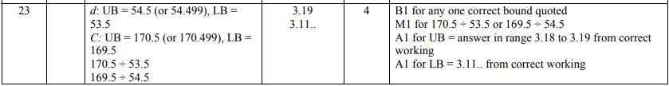
Pearson Edexcel - Monday 14 November 2011 - Paper 4 (Calculator) Higher Tier
5.
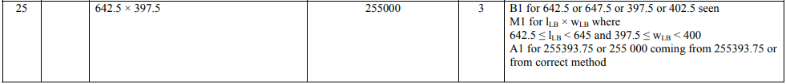
Pearson Edexcel - Friday 10 June 2011 - Paper 4 (Calculator) Higher Tier
6.
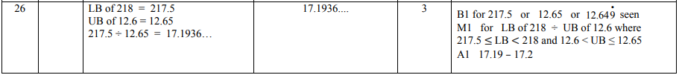
Pearson Edexcel - Friday 12 November 2010 - Paper 4 (Calculator) Higher Tier
7.
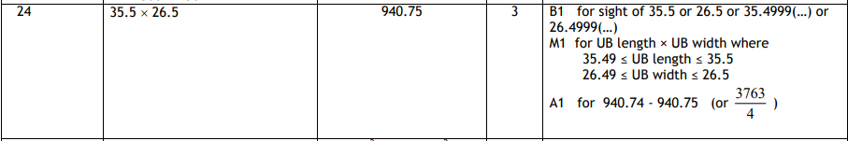
Pearson Edexcel - Friday 11 June 2010 - Paper 4 (Calculator) Higher Tier
8.
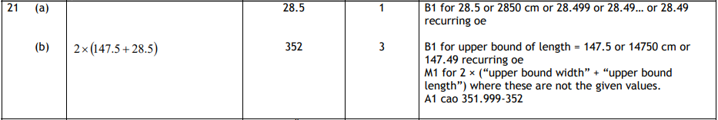
9.

